Modelling the Spread of mecA-Mediated Antibiotic Resistance in Staphylococcus aureus
Research Methods for Artificial Intelligence

Course code: IM1312
Student name: Alena Savachenko
Student number: 852897922

Contents
Abstract 1
Introduction 2
Background: Antibiotic Resistance 2
Antibiotic Resistance Mechanisms 2
Research question 3
Hypothese 3
Related Work 3
Methods 4
Experimental Design 4
Results 5
Overview of Simulation Runs 5
Population Dynamics Over Time 7
Statistical comparison, P-test 9
Conclusion 10
Discussion 10
Bibliography 11

Abstract

This research examines how horizontal gene transfer affects the spread of mecA-mediated antibiotic resistance in a Staphylococcus aureus population. An agent-based model was developed in NetLogo to evaluate two scenarios: vertical transmission alone and vertical transmission along with two horizontal gene transfer mechanisms: mobile genetic element (MGE)-mediated transfer and transformation. Each scenario was simulated ten times over 700 ticks, with a bacterial population of 850. The results demonstrated a significant difference between the two scenarios. Resistant bacteria comprised an average of 4.13% of the control population, compared to 99.32% in the experimental scenario. Welch's independent-samples t-test confirmed a statistically significant difference (p < 0.001). These results indicate that horizontal gene transfer can greatly accelerate the spread of antibiotic resistance in a simulated bacterial population.

Introduction

Background: Antibiotic Resistance

Antibiotics serve the dual purpose of preventing and treating bacterial infectious diseases. The phenomenon of antibiotic resistance arises when bacteria undergo changes as a reaction to the administration of these drugs(Ali, Rafiq, and Ratcliffe 2018; Partridge et al. 2018). Antibiotic resistance develops in bacteria, not in humans or animals. Such resistant bacteria have the potential to infect humans and animals, making the infections they cause more difficult to manage than those from non-resistant strains(Murray et al. 2022).
The implications of antibiotic resistance encompass heightened medical expenses, extended durations of hospitalization, and an increase in death rates.
Antibiotic resistance results from the evolutionary adaptation of bacterial populations, with the dissemination of resistance being contingent upon not just individual bacteria but also their interactions, genetic material transfer, and environmental factors(Murray et al. 2022).
Staphylococcus aureus - this bacterium can be found on human skin and mucous membranes, yet under certain conditions, it can lead to infections. Methicillin-resistant strains pose a significant challenge for treatment(Enright et al. 2002, 2002; Lakhundi and Zhang 2018). The mecA gene is responsible for producing an alternative penicillin-binding protein known as PBP2a which has a reduced affinity for the majority of beta-lactam antibiotics(Lade and Kim 2023; Lakhundi and Zhang 2018). Consequently, this allows the bacteria to continue synthesizing their cell wall despite the presence of these medications.

Antibiotic Resistance Mechanisms

Horizontal Gene Transfer (HGT) is the process by which genetic material is exchanged between bacteria that do not have a parent-child relationship(Avni and Snir 2020). This transfer can happen through methods like conjugation, transduction, or transformation, allowing bacteria to gain new characteristics, such as resistance to antibiotics(Lakhundi and Zhang 2018; Macedo et al. 2022; Partridge et al. 2018)
In contrast, Vertical Gene Transfer is the process of passing genetic material from a parent cell to its offspring during reproduction (bacterial division). For instance, if the parent bacterium has the mecA gene, it will be transmitted to the daughter cells(PDB101: Global Health: Antimicrobial Resistance: undefined: Overview of Antibiotic Resistance Mechanisms n.d.).
The primary difference lies in the fact that horizontal transfer spreads genes among bacteria, while vertical transfer is specifically from parent bacteria to their offspring.

Research question

How do bacterial reproduction and different transmission mechanisms , mobile genetic element transfer, transformation, and vertical inheritance affect the spread of the mecA gene in a population of Staphylococcus aureus?

Hypothese

Horizontal gene transfer of mecA, mediated by mobile genetic elements and transformation, accelerates the spread of antibiotic resistance in a Staphylococcus aureus population compared with vertical transmission alone

Related Work

Antimicrobial resistance presents a major challenge for modern healthcare. A prime example is methicillin-resistant Staphylococcus aureus(Enright et al. 2002; Lakhundi and Zhang 2018), which has acquired the mecA gene, enabling it to resist most beta-lactam antibiotics(Andersson and Hughes 2017; Lade and Kim 2023; Lakhundi and Zhang 2018). The emergence and spread of antibiotic resistance are driven by factors that extend beyond simple genetic mutations. Elements such as horizontal gene transfer, bacterial reproduction, environmental influences, and the pressure from antibiotics all contribute to the resistance dynamics observed in bacterial population(Andersson and Hughes 2017; Partridge et al. 2018; Souque, González Ojeda, and Baym 2024; Zhang, Tian, and Jin 2018). Although we have a solid understanding of the molecular mechanisms behind antibiotic resistance, it is essential to grasp how these mechanisms interact at the population level. Agent-based modeling provides a useful method to investigate these interactions by simulating individual bacteria and their connections within a population.
Therefore, this project aims to analyze how the transmission of the mecA resistance determinant impacts the dynamics of antibiotic resistance in a Staphylococcus aureus population.
While we have a good grasp of the molecular mechanisms that underlie antibiotic resistance, it is vital to understand how these mechanisms interact at the population level. Agent-based modeling serves as an effective tool to explore these interactions by simulating individual bacteria and their relationships within a population. As a result, this project intends to investigate how the transmission of the mecA resistance determinant influences the dynamics of antibiotic resistance in a Staphylococcus aureus population.

Methods

Experimental Design

Two experimental conditions are compared to investigate how horizontal gene transfer affects the spread of mecA-mediated antibiotic resistance in a bacterial population. For each condition, there are 10 independent simulation repetitions, and each of these simulations runs for a total of 700 ticks.
Comparison of the Experimental Groups

Model component |  | Control group | Experimental group
Bacterial reproduction |  | Yes | Yes
Vertical transmission of mecA |  | Yes | Yes
MGE-mediated horizontal gene transfer |  | No | Yes
Transformation |  | No | Yes

Table1. Description of the Experimental Conditions

Experiment 1. Control group:
Bacteria reproduce, and mecA is transmitted only vertically, from parent cells to their offspring. Horizontal gene transfer mechanisms are disabled.
Experiment 2. Experimental group:
Bacteria reproduce and transmit mecA vertically, as in the control group. In addition, two horizontal gene transfer mechanisms are enabled: MGE-mediated transfer and transformation.

The population was split into three groups according to how the mecA gene can be transmitted. These groups represent more than just three types of bacteria; they simulate various biological processes. In the 'experiment' group, we incorporated all three potential methods of gene transfer. The first two mechanisms are related to horizontal gene transfer (HGT), while the third one related to vertical transfer:
- MGE-mediated horizontal gene transfer involves the transfer of genes through mobile genetic elements like plasmids, bacteriophages, and other MGEs.
- Transformation refers to the process where bacteria absorb free DNA from their environment.
- Vertical transmission is the passing of genes from a parent bacterium to its offspring during reproduction (cell division).

Adjustable Model Parameters.
The model includes adjustable parameters that allow the simulation conditions to be varied, including the initial number of bacteria, the mecA transfer probability, and the bacterial reproduction probability.

Results

Overview of Simulation Runs

The simulation was done in two different situations: a control situation and an experimental situation. In the control situation, bacteria passed on their resistance through reproduction. In the experimental situation, we added new ways for bacteria to share genes, like mobile genetic elements (MGEs) and transformation. To handle random differences, we ran ten simulations for each situation. After 700 ticks, we looked at the final makeup of the population. The total number of bacteria stayed at 850 in both situations during all ten runs. This setup allowed us to focus on changes in the population's makeup instead of differences in the total number of bacteria. The simulation results for both conditions (control and experimental) are available in the project's GitHub repository: https://github.com/alena-sava/The-NetLogo-model

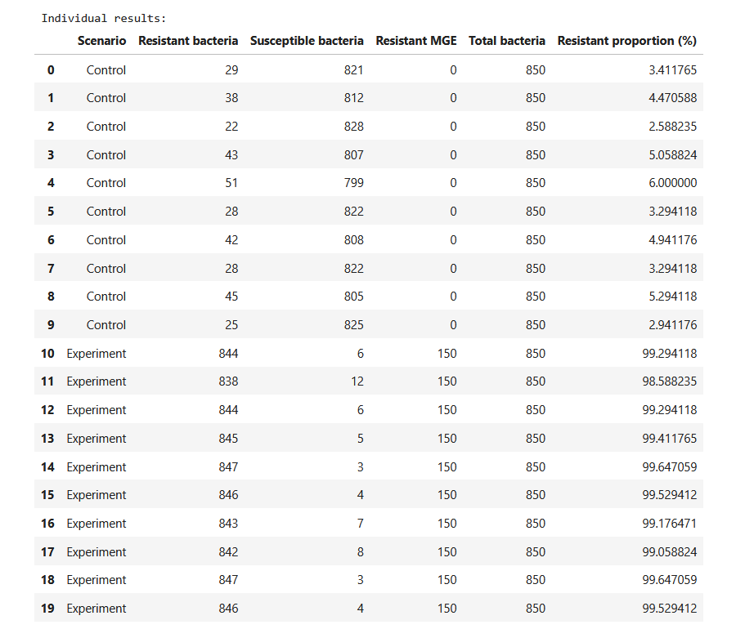
Table 1. Comparison of Resistant and Susceptible Bacteria in Control and Experimental Groups

A clear difference in bacterial populations was observed between the control and experimental conditions. In the control condition, the average number of resistant bacteria was 35.1 , while the average number of susceptible bacteria was 814.9. This means that resistant bacteria made up about 4.13% of the total bacteria. In contrast, the experimental condition showed a significant increase in resistant bacteria. The average count of resistant bacteria rose to 844.2 , while the average count of susceptible bacteria dropped to 5.8. As a result, the proportion of resistant bacteria increased to around 99.32% in the experimental condition, compared to just 4.13% in the control condition. These findings suggest that the use of horizontal gene transfer methods was associated with a significant change in the bacterial population, favoring antibiotic-resistant bacteria.

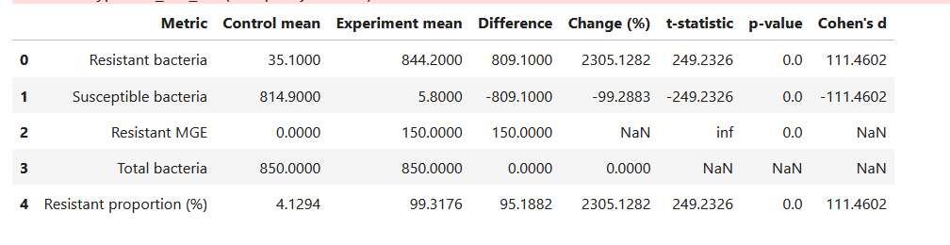 Table 2. Descriptive Statistics and Statistical Comparison of Control and Experimental Groups

Population Dynamics Over Time

The graph represents the variations in the number of resistant bacteria throughout 700 simulation ticks. In the experimental condition, the count of resistant bacteria rose sharply because of added horizontal gene transfer mechanisms, reaching over 800. In contrast, the control condition experienced only a minor increase, with resistant bacteria remaining a small fraction of the entire population.

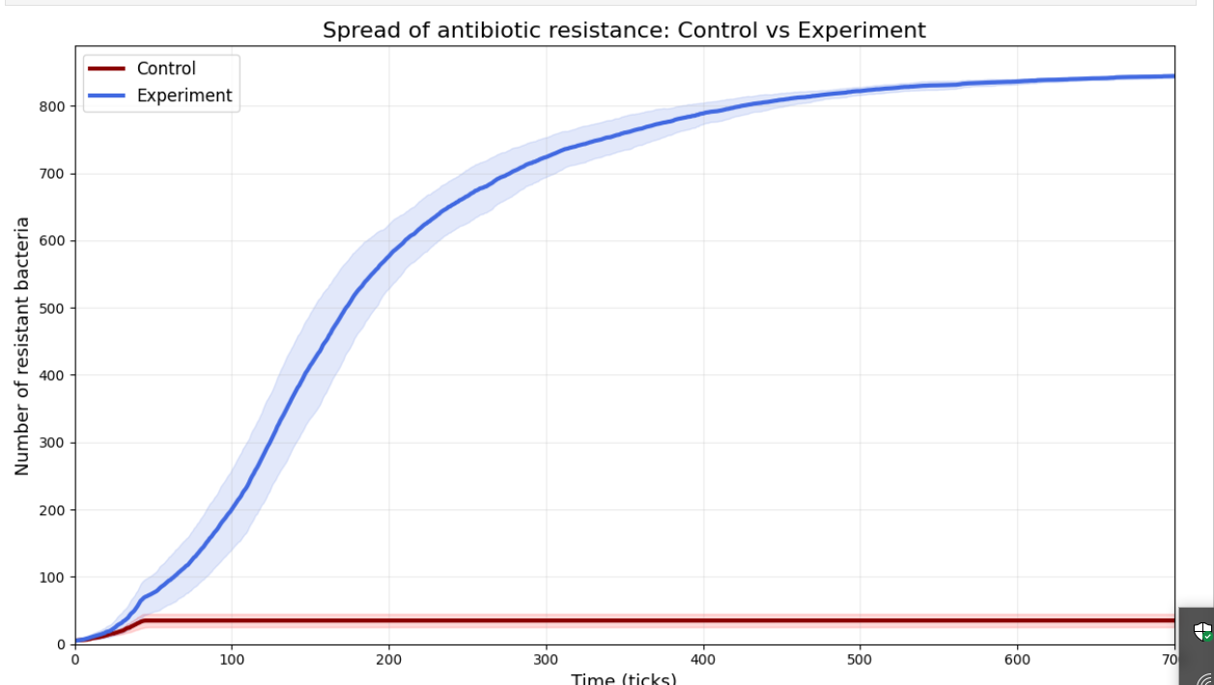
Figure 1. Changes in the number of resistant bacteria over 700 simulation ticks in the control and experimental conditions. Shaded areas represent variability across simulation runs.

The boxplot represents the distribution of resistant bacteria across ten simulation runs in both experimental setups. The experimental group had a significantly greater average of resistant bacteria (mean = 844.2) compared to the control group (mean = 35.1). This highlights a clear distinction in the levels of antibiotic resistance between the two experimental conditions.

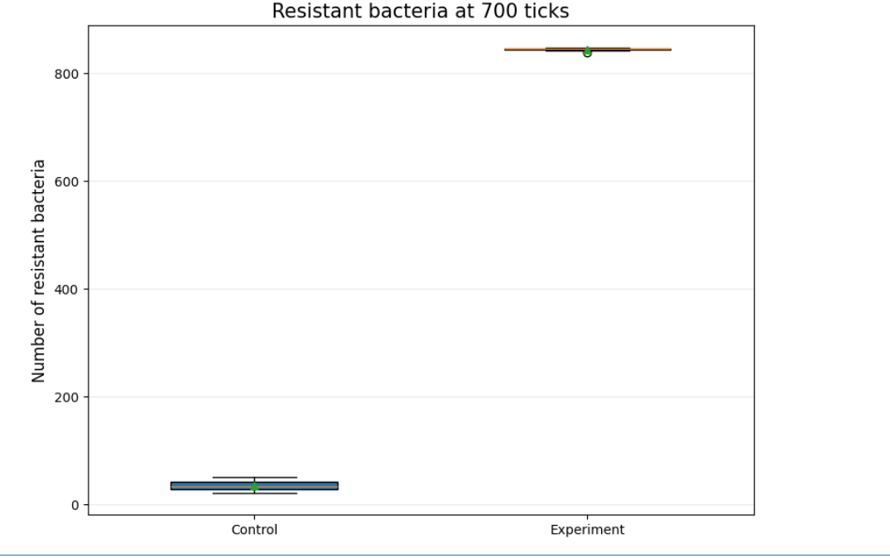
Figure 2. Comparison of Resistant Bacteria Counts at 700 Ticks.

Statistical comparison, P-test

The difference in the number of resistant bacteria between the control and experimental scenarios was assessed using Welch's independent-samples t-test.
The analysis indicated a highly significant difference between the two scenarios p < 0.001.

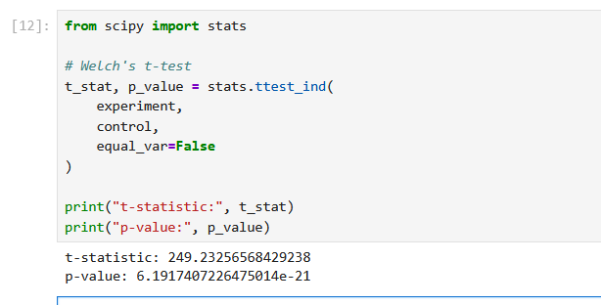
Figure3. P-value calculations

The simulation results, including the graphs and statistical analysis comparing the control and experimental conditions, are available in the project's GitHub repository:
https://github.com/alena-sava/The-NetLogo-model/tree/master/analysis

Conclusion

The simulation indicates a clear contrast in bacterial population dynamics when comparing vertical transmission alone to scenarios that also involve horizontal gene transfer processes. In the control group, resistant bacteria represented a small percentage, while the experimental conditions resulted in a nearly total prevalence of resistant bacteria. These outcomes strengthen the theory that horizontal gene transfer is a significant factor in the spread of mecA-mediated antibiotic resistance. To determine the relative influence of each mechanism, it would be important to conduct additional simulations that separate MGE-mediated transfer from transformation.

Discussion

The results show that horizontal gene transfer can greatly boost the spread of mecA-mediated antibiotic resistance. In the control scenario, resistant bacteria made up a small part of the population. However, when horizontal gene transfer mechanisms were introduced, resistant bacteria quickly became the majority, accounting for almost 99% of the population. This highlights the important role that horizontal gene transfer may play in the spread of antibiotic resistance. Both MGE-mediated transfer and transformation could contribute to this process. However, the model combines these two mechanisms, making it difficult to evaluate their individual impacts. Furthermore, the simulation presents a simplified view of the bacterial population and leaves out several factors that influence resistance spread in real bacterial communities. Despite these limitations, the findings support the idea that horizontal gene transfer can accelerate the spread of antibiotic resistance more effectively than vertical transmission alone.

Bibliography

Ali, Junaid, Qasim A. Rafiq, and Elizabeth Ratcliffe. 2018. “Antimicrobial Resistance Mechanisms and Potential Synthetic Treatments.” Future Science OA 4(4):FSO290. doi:10.4155/fsoa-2017-0109.
Andersson, Dan I., and Diarmaid Hughes. 2017. “Selection and Transmission of Antibiotic-Resistant Bacteria.” Microbiology Spectrum 5(4). doi:10.1128/microbiolspec.MTBP-0013-2016.
Avni, Eliran, and Sagi Snir. 2020. “A New Phylogenomic Approach For Quantifying Horizontal Gene Transfer Trends in Prokaryotes.” Scientific Reports 10:12425. doi:10.1038/s41598-020-62446-5.
Enright, Mark C., D. Ashley Robinson, Gaynor Randle, Edward J. Feil, Hajo Grundmann, and Brian G. Spratt. 2002. “The Evolutionary History of Methicillin-Resistant Staphylococcus Aureus (MRSA).” Proceedings of the National Academy of Sciences of the United States of America 99(11):7687–92. doi:10.1073/pnas.122108599.
Lade, Harshad, and Jae-Seok Kim. 2023. “Molecular Determinants of β-Lactam Resistance in Methicillin-Resistant Staphylococcus Aureus (MRSA): An Updated Review.” Antibiotics 12(9):1362. doi:10.3390/antibiotics12091362.
Lakhundi, Sahreena, and Kunyan Zhang. 2018. “Methicillin-Resistant Staphylococcus Aureus: Molecular Characterization, Evolution, and Epidemiology.” Clinical Microbiology Reviews 31(4):e00020-18. doi:10.1128/CMR.00020-18.
Macedo, Gonçalo, Asmus K. Olesen, Lorrie Maccario, Lucia Hernandez Leal, Peter v. d. Maas, Dick Heederik, Dik Mevius, Søren J. Sørensen, and Heike Schmitt. 2022. “Horizontal Gene Transfer of an IncP1 Plasmid to Soil Bacterial Community Introduced by Escherichia Coli through Manure Amendment in Soil Microcosms.” Environmental Science & Technology 56(16):11398–408. doi:10.1021/acs.est.2c02686.
Murray, Christopher J. L., Kevin Shunji Ikuta, Fablina Sharara, Lucien Swetschinski, Gisela Robles Aguilar, Authia Gray, Chieh Han, Catherine Bisignano, Puja Rao, Eve Wool, Sarah C. Johnson, Annie J. Browne, Michael Give Chipeta, Frederick Fell, Sean Hackett, Georgina Haines-Woodhouse, Bahar H. Kashef Hamadani, Emmanuelle A. P. Kumaran, Barney McManigal, Sureeruk Achalapong, Ramesh Agarwal, Samuel Akech, Samuel Albertson, John Amuasi, Jason Andrews, Aleskandr Aravkin, Elizabeth Ashley, François-Xavier Babin, Freddie Bailey, Stephen Baker, Buddha Basnyat, Adrie Bekker, Rose Bender, James A. Berkley, Adhisivam Bethou, Julia Bielicki, Suppawat Boonkasidecha, James Bukosia, Cristina Carvalheiro, Carlos Castañeda-Orjuela, Vilada Chansamouth, Suman Chaurasia, Sara Chiurchiù, Fazle Chowdhury, Rafai Clotaire Donatien, Aislinn J. Cook, Ben Cooper, Tim R. Cressey, Elia Criollo-Mora, Matthew Cunningham, Saffiatou Darboe, Nicholas P. J. Day, Maia De Luca, Klara Dokova, Angela Dramowski, Susanna J. Dunachie, Thuy Duong Bich, Tim Eckmanns, Daniel Eibach, Amir Emami, Nicholas Feasey, Natasha Fisher-Pearson, Karen Forrest, Coralith Garcia, Denise Garrett, Petra Gastmeier, Ababi Zergaw Giref, Rachel Claire Greer, Vikas Gupta, Sebastian Haller, Andrea Haselbeck, Simon I. Hay, Marianne Holm, Susan Hopkins, Yingfen Hsia, Kenneth C. Iregbu, Jan Jacobs, Daniel Jarovsky, Fatemeh Javanmardi, Adam W. J. Jenney, Meera Khorana, Suwimon Khusuwan, Niranjan Kissoon, Elsa Kobeissi, Tomislav Kostyanev, Fiorella Krapp, Ralf Krumkamp, Ajay Kumar, Hmwe Hmwe Kyu, Cherry Lim, Kruy Lim, Direk Limmathurotsakul, Michael James Loftus, Miles Lunn, Jianing Ma, Anand Manoharan, Florian Marks, Jürgen May, Mayfong Mayxay, Neema Mturi, Tatiana Munera-Huertas, Patrick Musicha, Lilian A. Musila, Marisa Marcia Mussi-Pinhata, Ravi Narayan Naidu, Tomoka Nakamura, Ruchi Nanavati, Sushma Nangia, Paul Newton, Chanpheaktra Ngoun, Amanda Novotney, Davis Nwakanma, Christina W. Obiero, Theresa J. Ochoa, Antonio Olivas-Martinez, Piero Olliaro, Ednah Ooko, Edgar Ortiz-Brizuela, Pradthana Ounchanum, Gideok D. Pak, Jose Luis Paredes, Anton Yariv Peleg, Carlo Perrone, Thong Phe, Koukeo Phommasone, Nishad Plakkal, Alfredo Ponce-de-Leon, Mathieu Raad, Tanusha Ramdin, Sayaphet Rattanavong, Amy Riddell, Tamalee Roberts, Julie Victoria Robotham, Anna Roca, Victor Daniel Rosenthal, Kristina E. Rudd, Neal Russell, Helio S. Sader, Weerawut Saengchan, Jesse Schnall, John Anthony Gerard Scott, Samroeng Seekaew, Mike Sharland, Madhusudhan Shivamallappa, Jose Sifuentes-Osornio, Andrew J. Simpson, Nicolas Steenkeste, Andrew James Stewardson, Temenuga Stoeva, Nidanuch Tasak, Areerat Thaiprakong, Guy Thwaites, Caroline Tigoi, Claudia Turner, Paul Turner, H. Rogier van Doorn, Sithembiso Velaphi, Avina Vongpradith, Manivanh Vongsouvath, Huong Vu, Timothy Walsh, Judd L. Walson, Seymour Waner, Tri Wangrangsimakul, Prapass Wannapinij, Teresa Wozniak, Tracey E. M. W. Young Sharma, Kalvin C. Yu, Peng Zheng, Benn Sartorius, Alan D. Lopez, Andy Stergachis, Catrin Moore, Christiane Dolecek, and Mohsen Naghavi. 2022. “Global Burden of Bacterial Antimicrobial Resistance in 2019: A Systematic Analysis.” The Lancet 399(10325):629–55. doi:10.1016/S0140-6736(21)02724-0.
Partridge, Sally R., Stephen M. Kwong, Neville Firth, and Slade O. Jensen. 2018. “Mobile Genetic Elements Associated with Antimicrobial Resistance.” Clinical Microbiology Reviews 31(4):e00088-17. doi:10.1128/CMR.00088-17.
PDB101: Global Health: Antimicrobial Resistance: undefined: Overview of Antibiotic Resistance Mechanisms. n.d. Retrieved November 1, 2026. https://pdb101.rcsb.org/global-health/antimicrobial-resistance/drugs/antibiotic-resistance-mechanisms/overview-of-antibiotic-resistance-mechanisms.
Souque, Célia, Indra González Ojeda, and Michael Baym. 2024. “From Petri Dishes to Patients to Populations: Scales and Evolutionary Mechanisms Driving Antibiotic Resistance.” Annual Review of Microbiology 78(1):361–82. doi:10.1146/annurev-micro-041522-102707.
Zhang, Qian-Qian, Guang-Ming Tian, and Ren-Cun Jin. 2018. “The Occurrence, Maintenance, and Proliferation of Antibiotic Resistance Genes (ARGs) in the Environment: Influencing Factors, Mechanisms, and Elimination Strategies.” Applied Microbiology and Biotechnology 102(19):8261–74. doi:10.1007/s00253-018-9235-7.

